2016 RMAA CONVENTION BRONZE SPONSORS:

______________________________________________________________________________
AECOM CANADA LTD. – BRONZE SPONSOR
______________________________________________________________________________

A.J Harlick Earthmoving - BRONZE SPONSOR
______________________________________________________________________________

bar engineering - bronZE SPONSOR

BOYD PETROSEARCH – BRONZE SPONSOR
______________________________________________________________________________
CAA TRAVEL – BRONZE SPONSOR

Chamney Crushing - BRONZE SPONSOR
______________________________________________________________________________
C.I.B.C. - BRONZE SPONSOR
______________________________________________________________________________
Cogent Business Consulting - BRONZE SPONSOR
______________________________________________________________________________
Cornerstone Credit Union - BRONZE SPONSOR
______________________________________________________________________________
Holm RAiche OBERG C.A. - BRONZE SPONSOR
_____________________________________________________________________________
MOBILE PAVING – BRONZE SPONSOR

Moose Jaw Refinery - BRONZE SPONSOR
______________________________________________________________________________
PALLISER AGGREGATES - BRONZE SPONSOR
______________________________________________________________________________
Percy H. Davis Ltd. - BRONZE SPONSOR
______________________________________________________________________________
Procyk Bros. Transport- BRONZE SPONSOR
______________________________________________________________________________
Robb & Dowling - BRONZE SPONSOR

Saskatchewan Blue Cross - BRONZE SPONSOR
Saskatchewan Blue Cross was founded in 1946 as a Saskatchewan owned not-for-profit committed to the improved health and wellness of Saskatchewan residents. Recognized since 2002 as one of the Top 100 Companies in Saskatchewan, we continue to lead in providing health benefit solutions to both groups and individuals, and in giving back to the community that supports us.
Saskatchewan Blue Cross is a member of the Canadian Association of Blue Cross Plans; together Blue Cross companies are the largest carrier of health and dental benefits in Canada. We have international links to other health benefit providers through the Blue Cross Blue Shield Association and the worldwide International Federation of Health Funds.
______________________________________________________________________________
Shaw Earth Moving Inc. - BRONZE SPONSOR
______________________________________________________________________________
VANTAGE PROFESSIONAL ACCOUNTANTS – BRONZE SPONSOR

Western Litho - BRONZE SPONSOR

RMAA CONVENTION SILVER SPONSORS:
______________________________________________________________________________
AGRICULTURAL PRODUCERS ASSOCIATION OF sASKATCHEWAN – SILVER SPONSOR
______________________________________________________________________________
COLLINS BARROW – SILVER SPONSOR

D & R Contracting Ltd. - SILVER SPONSOR
______________________________________________________________________________
Ducks Unlimited- SILVER SPONSOR

FOSTERS WINE ESTATES CANADA – SILVER SPONSOR
______________________________________________________________________________
MOrTIMER BROTHERS CONSTRUCTION – SILVER SPONSOR

PLAINS Midstream Canada- SILVER SPONSOR
______________________________________________________________________________
Redhead Equipment- SILVER SPONSOR

Sask Energy- SILVER SPONSOR
______________________________________________________________________________
SaskTel- SILVER SPONSOR
______________________________________________________________________________
SPECTRA ENERGY EMPRESS L.P. - SILVER SPONSOR
______________________________________________________________________________
WESTERN MUNICIPAL TAX SOLUTIONS – SILVER SPONSOR
______________________________________________________________________________

RMAA CONVENTION GOLD SPONSORS:

20/20 GEOMATICS LTD. – GOLD SPONSOR

AMEC FOSTER WHEELER Environmental - GOLD SPONSOR
______________________________________________________________________________

Anderson Rental & Paving - GOLD SPONSOR

CUSTOM TRUCK SALES – GOLD SPONSOR
______________________________________________________________________________
CRESCENT POINT RESOURCES - GOLD SPONSOR
______________________________________________________________________________
Munisoft- GOLD SPONSOR
MuniSoft, now celebrating 25 years of working with municipal government, offers specialized computer software and services for local government administration and finance including solutions for taxation, utilities, accounting, cemetery management, tangible capital asset management, job costing, mapping and more. MuniSoft serves a clientele of nearly 700 local governments across Canada.

PRAIRIE STEEL PRODUCTS LTD. – GOLD SPONSOR
______________________________________________________________________________
Professional Building Inspections Inc. - GOLD SPONSOR
PROFESSIONAL BUILDING INSPECTIONS, INC. (PBI) HAS BEEN IN BUSINESS SINCE 1991 AND IS SASKATCHEWAN’S LARGEST BUILDING CODE INSPECTION COMPANY.
ALL OF OUR INSPECTORS ARE CLASS 1 TO CLASS 3 LICENSED BUILDING OFFICIALS WHO PROVIDE RESIDENTIAL, COMMERCIAL, INDUSTRIAL AND INSTITUTIONAL NATIONAL BUILDING CODE (NBC) COMPLIANCE SERVICES TO OVER A HUNDRED URBAN AND RURAL MUNICIPALITIES IN SOUTHERN SASKATCHEWAN.
PBI HAS A HEAD OFFICE IN WHITE CITY (NEAR REGINA), AN AFFILIATE NEAR SASKATOON, AND SATELLITE LOCATIONS IN WEYBURN AND ESTERHAZY TO SERVE YOU BETTER!
PLEASE VISIT OUR WEBSITE AT WWW.PRO-INSPECTIONS.CA FOR MORE DETAILS

RBC – Royal Bank- GOLD SPONSOR
______________________________________________________________________________
TIM A. Cheeseman Planning CONSULTANTS - GOLD SPONSOR
(Tim Cheeseman, Karen Sander, Dwight Mercer)
______________________________________________________________________________

RMAA CONVENTION PLATINUM SPONSORS:

CANADA CULVERT - PLATINUM SPONSOR

DELTA HOTEL REGINA – PLATINUM SPONSOR
FINNING CANADA – PLATINUM SPONSOR
______________________________________________________________________________
MAXIM CHEMICAL INTERNATIONAL - PLATINUM SPONSOR
______________________________________________________________________________
MINISTRY OF GOVERNMENT RELATIONS - PLATINUM SPONSOR
______________________________________________________________________________
RESOURCE MANAGEMENT INTERNATIONAL INC. - PLATINUM SPONSOR
_____________________________________________________________________________
SASK POWER- PLATINUM SPONSOR

Signal Industries Ltd. - PLATINUM SPONSOR
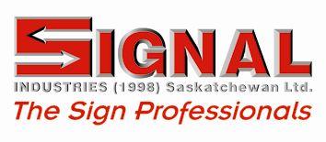

Signal Industries, in its 40 years of operation, has grown from a leading manufacturer of traffic control signs to include: Electronic Message Centers (EMCs), lower cost monument signs, dimensional letters, architectural signs, banners, vehicle, asset, sequential numbering bar codes, wide format digital printing and custom design.

W.F. BOTKIN CONSTRUCTION LTD. - PLATINUM SPONSOR
______________________________________________________________________________
WSP – PLATINUM SPONSOR
______________________________________________________________________________

RMAA CONVENTION DIAMOND SPONSORS:

S.A.R.M. – DIAMOND SPONSOR
______________________________________________________________________________

RMAA CONVENTION TRIPLE DIAMOND SPONSOR:

SASKATCHEWAN MUNICIPAL HAIL INSURANCE ASSOCIATION (SMHI) – TRIPLE DIAMOND
SPONSOR

TRADE SHOW BOOTHS
______________________________________________________________________________
Airmaster Sales Ltd. - TRADE SHOW BOOTH
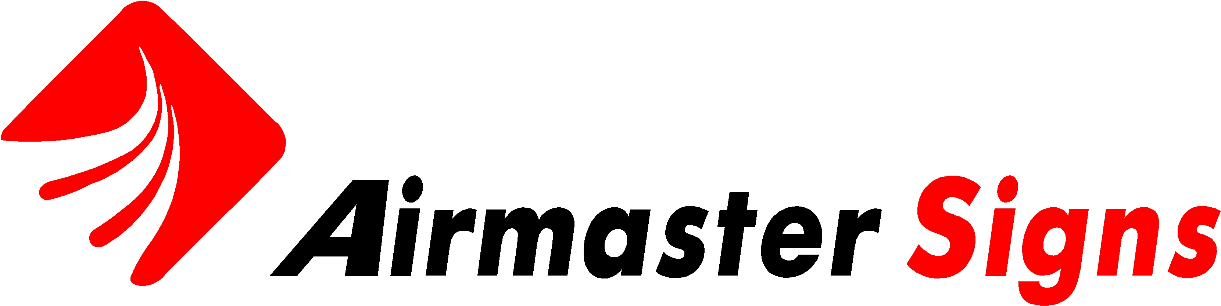
Airmaster Signs is a local Canadian sign company, manufacturing top quality traffic signs and accessories to the Saskatchewan municipal market for over 15 years
______________________________________________________________________________
A.P.A.S. / myRM.com – TRADE SHOW BOOTH

G.W.P. Rodent Products Inc. - TRADE SHOW BOOTH
______________________________________________________________________________
Information Services Corporation- TRADE SHOW BOOTH
____________________________________________________________________________
loraas environmental services – trade show booth
_____________________________________________________________________________
M.E.P.P. - TRADE SHOW BOOTH
______________________________________________________________________________
MuniSoft- TRADE SHOW BOOTH
______________________________________________________________________________

Prairie Mapping Services- TRADE SHOW BOOTH
Your one stop source for all your municipal G.I.S. mapping needs including wall maps, map books, electronic updating and G.P.S. data collection surveys. A complete line of products and services at one location. Contact us at 647-2350 or visit our website at www.prairiemapping.com

Sask. Assessment Management Agency- TRADE SHOW BOOTH
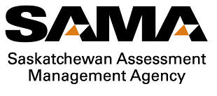
The Saskatchewan Assessment Management Agency (SAMA) is responsible for property assessment governance for the entire province. This includes assessment research and policy development, maintaining a comprehensive assessment database, conducting quality assurance including confirmation of all assessment rolls and providing assessment information to government in support of the $70 billion assessment base used to generate approximately $1.4 billion in annual revenue to fund municipal services and K to 12 education. SAMA also conducts assessment services for 757 of the 775 municipalities in Saskatchewan, determining, delivering and supporting assessed values for each of our client municipalities. The Agency delivers approximately 35,000 completed assessment maintenance requests to our 757 client municipalities annually. SAMA also coordinates a full revaluation of all properties in the province every four years. The previous revaluation in the province was completed in 2009, using June 30, 2006 as the base date. The base date is the date to which the assessed values are related. The next revaluation will occur in 2013 and will use January 1, 2011 as the base date.
SAMA conducts targeted reinspection programs as resources allow, and ensures assessments are supported through the appeal processes.
______________________________________________________________________________
S.A.R.M. – TRADE SHOW BOOTH
______________________________________________________________________________
Success Office Systems - TRADE SHOW BOOTH

TAXERVICE – TRADE SHOW BOOTH
______________________________________________________________________________
Western Municipal Tax Solutions - TRADE SHOW BOOTH
______________________________________________________________________________
wsp canada inc. - traDE SHOW BOOTH

